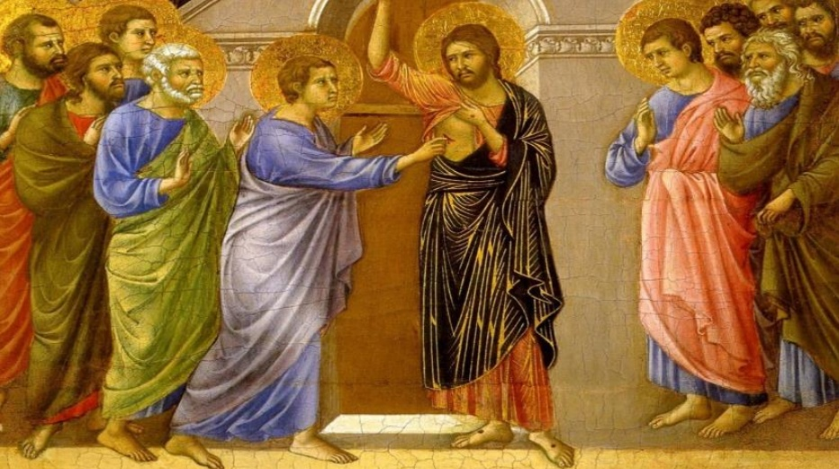

The Complexity of Our Faith

Faith is very complex and is not always easy to come to. Some people need a solid and unquestionable miracle of God to believe in Him...while others can come to believe, simply by hearing the testimonies of others. I’m confident to say that most have not experienced divine apparitions, miraculous healings, or some other type of miracle...though they do happen...but rather, most have heard the life stories of those who’ve been touched by God in some profound way in their lives. Providing that these testimonies are based on sound doctrine, the basis of our Catholic faith, they can be relied upon to strengthen our own faithlife...causing us to believe.

In today’s Gospel from John we hear the story of Jesus appearing to His disciples as they were locked in the upper room. He immediately sets them at ease by offering them His peace, and then He breathes the Holy Spirit on them...sending them to preach the gospel, and reconciling others to Him. However Thomas, one His apostles was not there that evening and didn’t believe the accounts the others gave him. A week later, when they were all there, Jesus appeared to them again and singled out Thomas, asking him to touch His wounds in His side and in His hands, saying to him, “Do not be unbelieving, but believe.” To which Thomas responded, “My Lord and my God!” Jesus then said to him, “Have you come to believe because you have seen me? Blessed are those who have not seen and have believed.”

Jesus calls us to faith with these powerful words. He acknowledges that seeing is believing, and is truly the most sensible and logical way to come to faith...and yes, Christ does encourage us to, “ask, seek, and knock” to receive blessings from heaven; however, personally “seeing” or “receiving” should not be the basis of our faith. John concludes his gospel by encouraging all of us to believe in his testimony, “Now, Jesus did many other signs in the presence of his disciples that are not written in this book. But these are written that you may come to believe that Jesus is the Christ, the Son of God, and that through this belief you may have life in his name.” Though most of us are called to faith without personal experiences, we rely on the faith of those who have gone before us...our friends and family members...but ultimately upon the eyewitness accounts of the apostles and the disciples themselves, such as in John’s gospel. Anything we receive beyond these accounts...any encounter with the divine, beyond these public revelations of the canons, is grace. And yet, grace is what we all receive at every Mass when Christ’s body and blood are made present and available to us in the Holy Eucharist...the most intimate of encounters with Christ as He permits us to take Him within our own bodies.

Jesus was gentle with Thomas, even though he had initially doubted His resurrection...and He is also patient and gentle with us in our own personal faith journey. “Faith comes from what is heard, and what is heard comes through the word of Christ.” (Romans 10:17). St . Paul understood that faith is extremely complex and that most of us have never experienced these concrete encounters with Christ to help us believe. Yet, he stresses that, by hearing the testimonies of others who base their faith on sound doctrine...the word of Christ, through scripture...we can draw close to Him who encourages us to “[believe without seeing].” Faith is a journey that many of us struggle with...yet with the desire to believe, God will certainly provide the necessary grace to build and strengthen our faith in time. So whenever we struggle with our faith, let us keep this simple prayer in mind, found in Mark’s gospel, “Lord, I do believe...help my unbelief.” (Mark 9:24)

St. Thomas, Pray for us!

Peace,

Deacon Tom Caporuscio

